**Software Requirement Specification (SRS)**

Of

**Finance and Accounting module (SLCM)**

For Implementation of

**Campus Management Software**

at

**World Skill Center (WSC)**

**Sustainable Outreach And Universal**

**Leadership (SOUL) Limited**

**Table of Content**

A. Abstract 3

B. Introduction 3

C. Definition, Acronyms and Abbreviations 3

D. Overview of the Document 3

E. Scope of Accounting Module 4

F. WSC Finance Accounting Process Flow 4

G. Process Flow Description 5

H. List of Screens and Their Descriptions 6

1. SLCM 7

1.1 Fee Structure 7

1.2 Fee Schedule 9

1.3 Fees 12

1.4 Program Enrollment 17

1.5 Student Re registration Tool 23

1.6 Fee Waiver 25

# Abstract

Software Requirements Gathering is one of the first phases of system development. This phase results in the Software Requirements Specification (SRS) document, which must contain a complete, concise, high-quality description of the system being considered.

# Introduction

The World Skill Center (WSC) is a premier advanced skill training institute established by the Government of Odisha, Skill Development and Technical Education Department, through the Odisha Skill Development Authority (OSDA). The WSC will impart advanced skill training in eight trades from engineering and service sectors. WSC caters primarily to induct the best talent from ITIs and Polytechnics and train them to become globally employable in emerging areas such as "Industry 4.0". WSC is housed in a state-of-the-art, 18-storey, air-conditioned building with nearly half a million square feet of space in the heart of capital city of Bhubaneswar.

With the Implementation of campus management software for WSC the goal is to streamline the operations and functions of the campus by integrating various processes, such as admissions, course registration, academic progress tracking, and financial management, HRMS, Procurement and Inventory management, etc into a unified system. The implementation also aims at providing a user-friendly interface for all stakeholders, making it easier for them to access the necessary information and complete their tasks with ease. The modules to be covered during the implementation of the software includes:

|  |  |
| --- | --- |
| Students Management Modules | Infrastructure Management |
| Academic System | Finance and Accounting System |
| Procurement & Inventory Management | Training and Placement |
| Human Resources Management System | Application Integration |

# Definition, Acronyms and Abbreviations

The following table explains the terms and abbreviations used in the document:

|  |  |
| --- | --- |
| **Abbreviation** | **Description** |
| SRS | Software Requirements Specification |
| R | Rename - When a field is Renamed |
| N | New - When a New field is Added |
| D | Delete - When an Existing field is Deleted |
| NA | Not Applicable |

# Overview of the Document

This requirement document provides a detailed overview of the functional requirements of a project. It serves as a communication tool between stakeholders, including developers, project managers, and end-users. The purpose of this requirement document is to define and document the project's objectives, scope, and expectations, and to ensure that all stakeholders have a clear understanding of what the project entails.

This document covers all the functional requirements of the **Finance and Accounting module** considering all process in Education module of ERP Product. This helps in organizing the Chart of Fee Structure, Fee Schedule, Fees, Program Enrollment, Student Re registration Tool, Fee Waiver  etc.

# Scope of Accounting Module

* Receipt and Payment Entries
* Direct Transfer of Caution Money to Student’s Accounts
* Demand Register
* Caution Money Register
* Bank Reconciliation Statement
* Generation of Cash Book (PL)
* Grants-in-aid Register
* Paid Voucher Register
* Advances Register
* Auditing and Tracking Pendency of Audit paras etc.

# WSC Finance Accounting Process Flow

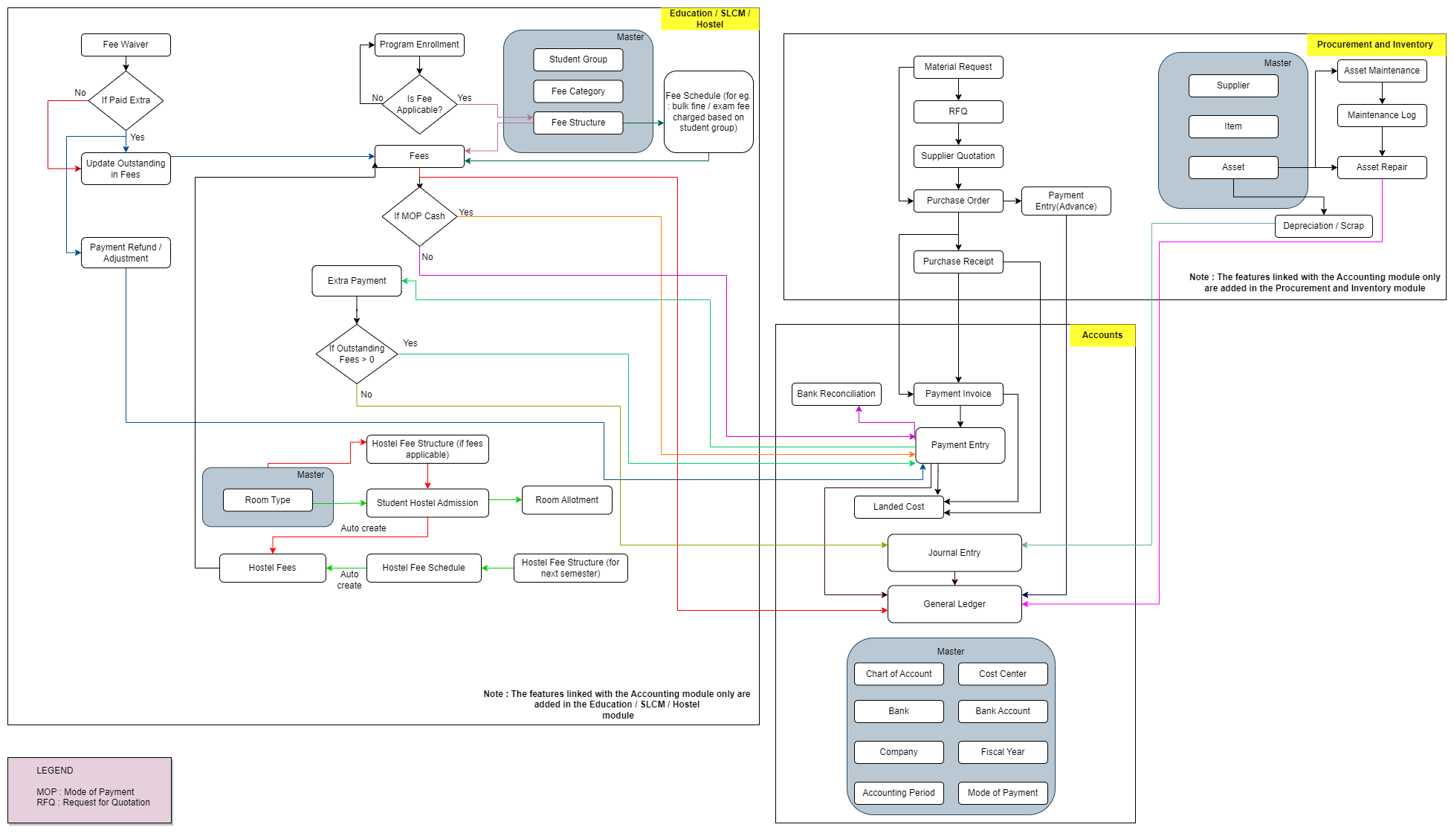

Note : The features linked with the Accounting Module are added in this flowchart

# **Process Flow Description**

**Accounts Masters**

Accounts Master represents the conFigureuration such as Chart of Accounts, Cost center, Bank, Bank Account, Company, Fiscal Year, Accounting Period , Mode of Payment etc.

**SLCM Masters**

Student Group, Fee Category and Fee Structure are the masters which are required for the functioning of the accounts module.

**Procurement and Inventory Masters**

Supplier, Item and Asset are the master which are essential for the accounting processes to be functional with respect to the Material Management module.

**Fee Waiver**

Fee waiver refers to an exemption or reduction of a student's fees that they would normally be required to pay in order to enroll in classes or participate in certain activities.

**Fees**

In this form, Fee Records of the students can be maintained.

**Fee Schedule**

Fee Schedule would help in defining a time-line for the Fee payment of the students, based on the Student Group.

**Payment Invoice**

A Purchase Invoice is a bill you receive from your Suppliers against which you need to make the payment.

**Payment Entry**

Payment Entry is a record indicating that payment has been made for an invoice.

Payment Entry can be made against the following transactions:

1. Sales Invoice
2. Purchase Invoice
3. Sales Order (Advance Payment)
4. Purchase Order (Advance Payment)
5. Expense Claim
6. Internal Transfer

**Bank Reconciliation**

Once all your bank transactions are imported into the application, you can reconcile them with your existing vouchers.

**Journal Entry**

A Journal Entry is an entry made in the general ledger and it indicates the affected accounts.

**General Ledger**

The General Ledger is a detailed report for all transactions posted to each account and for every transaction there is a Credit and Debit account so it lists them all up.

# **List of Screens and Their Descriptions**

|  |  |  |
| --- | --- | --- |
| **ID** | **Screen Name** | **Description** |
|  | Fee Structure | A Fee Structure is a template that can be used while making Fees records or generating them via the Fee Schedule. |
|  | Fee Schedule | Fee Schedule would help in defining a time-line for the Fee payment of the students, based on the Student Group. |
|  |  |  |
|  | Fees | In this form, Fee Records of the students can be maintained. |
|  | Program Enrollment | Program Enrollment is the record of enrollment of a student in a given program and chosen courses for a particular Academic Term. |
|  | Student Re registration Tool | Student Re registration tool mainly help for enrolling the students into their next semester bulk wise only after the enrollment of first semester. |
|  | Fee Waiver | Fee waiver refers to an exemption or reduction of a student's fees that they would normally be required to pay in order to enroll in classes or participate in certain activities. |

## SLCM

### Fee Structure

**General Description**

The following table describes overall information about this screen:

|  |  |
| --- | --- |
| **Description** | A Fee Structure is a template that can be used while making Fees records or generating them via the Fee Schedule. |
| **Navigation** | Home > Admission > Fees > Fee Structure |
| **Pre-requisites** | 1. Fee Type 2. Programs 3. Program Grade 4. Fee Type 5. Student Category 6. Semester 7. Academic Year 8. Academic Term |
| **Existing Screen Name** | Fee Structure |
| **New Screen Name** | None |

**Screenshot**

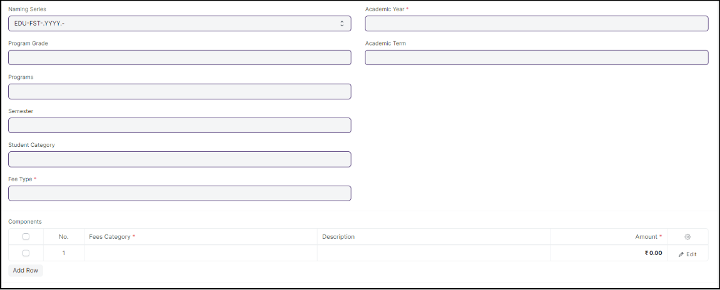

Figure :Fee Structure screen

**Field List**

The following table describes the UI fields present in this screen :

|  |  |  |  |  |  |  |
| --- | --- | --- | --- | --- | --- | --- |
| **ID** | **Field Name** | **Field Type** | **Mandatory** | **Validation/Action** | **Remarks** | **R/N/D** |
| 1 | Program Grade | Link Field |  | Linked to Program Grade |  | (R) Course Grade |
| 2 | Programs | Link Field |  | Linked to Programs Screen |  | (R) Course |
| 3 | Semester | Link Field |  | Linked to Semester Screen |  |  |
| 4 | Student Category | Link Field |  | Linked to Student Category Screen |  |  |
| 5 | Fee Type | Link Field | Yes | Linked to Fee Type Screen |  |  |
| 6 | Exam Type | Link Field |  | Linked to Exam Type Screen |  |  |
| 7 | Academic Year | Link Field | Yes | |  | | --- | | Linked to Academic Year Screen | |  |  |
| 8 | Academic Term | Link Field |  | Linked to Academic Term Screen |  |  |
| 9 | **Components** | Table |  | Description of the table is given below |  |  |
| 10 | Total Amount | Currency |  |  |  |  |
| 11 | Company | Link Field |  | Linked to Cost Center Screen |  |  |
| 12 | Cost Center | Link Field |  |  |  |  |
| 13 | Create Fee Schedule | Button |  | Redirects to Fee Schedule Screen |  |  |

|  |  |  |  |  |  |  |
| --- | --- | --- | --- | --- | --- | --- |
| **Component** | | | | | | |
| **ID** | **Field Name** | **Field Type** | **Mandatory** | **Validation/ Action** | **Remarks** | **R/N/D** |
| 1 | Fees Category | Link Field | Yes | Link Fields to master screen Fee Category |  |  |
| 2 | Description | Long Text |  |  |  |  |
| 3 | Amount | Currency | Yes |  |  |  |
| 4 | Waiver Type | Dropdown |  | Amount  Percentage |  |  |
| 5 | Percentage | Float |  |  |  |  |
| 6 | Waiver Amount | Currency |  |  |  |  |
| 7 | Total waiver Amount | Currency |  |  |  |  |
| 8 | Receivable Account | Link Field | Yes | Link Fields to Account Screen |  |  |
| 9 | Income Account | Link Field | Yes | Link Fields to Account Screen |  |  |
| 10 | Company | Link Field |  | Link Fields to Company Screen |  |  |
| 11 | Grand Fee Amount | Currency |  |  |  |  |
| 12 | Outstanding Fees | Currency |  |  |  |  |

**Users: Roles and Permissions**

The following table describes the users and their roles and permissions for the screens :

|  |  |  |  |  |  |  |  |  |
| --- | --- | --- | --- | --- | --- | --- | --- | --- |
| **ID** | **Role** | **Read** | **Write** | **Create** | **Delete** | **Submit** | **Cancel** | **Amend** |
| 1 | Account User | Yes | Yes | Yes | Yes | No | No | No |
| 2 | Account Manager | Yes | Yes | Yes | No | Yes | No | No |
| 3 | Accountant Admin | Yes | Yes | Yes | Yes | Yes | Yes | Yes |

### Fee Schedule

**General Description**

The following table describes overall information about this screen:

|  |  |
| --- | --- |
| **Description** | Fee Schedule would help in defining a time-line for the Fee payment of the students, based on the Student Group. |
| **Navigation** | Home > Admission > Fees > Fee Schedule |
| **Pre-requisites** | Fee Structure |
| **Existing Screen Name** | Fee Schedule |
| **New Screen Name** | None |

**Screenshot**

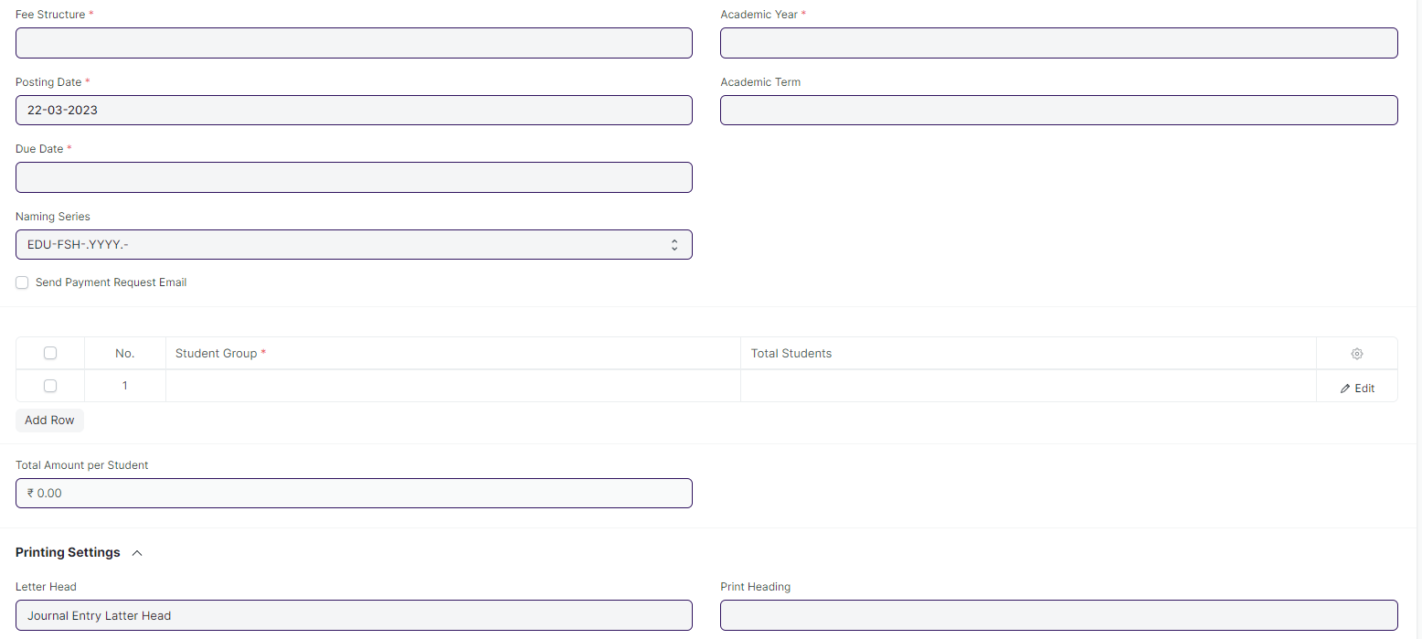 Figure: Fee Schedule

**Field List**

The following table describes the UI fields present in this screen :

|  |  |  |  |  |  |  |
| --- | --- | --- | --- | --- | --- | --- |
| **ID** | **Field Name** | **Field Type** | **Mandatory** | **Action / Validation** | **Remarks** | **R/N/D** |
| 1 | Fee Structure | Link Field | Yes | Link Fielded to Fee Structure Screen |  |  |
| 2 | Posting Date | Date | Yes |  |  |  |
| 3 | Due Date | Date | Yes |  |  |  |
| 4 | Fee Creation Status | Dropdown |  | In Process  Failed  Successful |  |  |
| 5 | Send Payment Request Email | Checkbox |  | If checked mail will be triggered form payment request |  |  |
| 7 | Student Category | Link Field |  | Links to Student Category screen |  |  |
| 8 | Programs | Link Field |  | Links to Programs Screen |  | ( R ) Course |
| 9 | Program | Link Field |  | Links to Semester Screen |  | (R) Semester |
| 10 | Academic Year | Link Field | Yes | Links to Academic Year |  |  |
| 11 | Academic Term | Link Field |  | Links to Academic Term |  |  |
| 13 | Currency | Link Field |  | Links to Currency Screen |  |  |
| 14 | **Student Group** | Table | Yes | 1. filtered will be applied on the basis of inputted semester and academic term 2. Description of the table given below |  |  |
| 16 | **Fee Components** | Table |  | Description of the table given below |  |  |
| 19 | Total Amount per Student | Currency |  |  |  |  |
| 20 | Grand Total | Currency |  |  |  |  |
| 21 | In Words | Text |  |  |  |  |
| 23 | Letter Head | Link Field |  | Links to the Letter head screen |  |  |
| 25 | Print Heading | Link Field |  | Links to Print Heading Screen |  |  |
| 27 | Receivable Account | Link Field |  | Links to Receivable Account |  |  |
| 28 | Income Account | Link Field |  | Links to Income Account |  |  |
| 30 | Institution | Link Field |  | Links to Company Screen |  |  |
| 32 | Cost Center | Link Field |  | Links to Cost Center Screen |  |  |
| 33 | View Fee Records | Button |  | Redirects to Fees List |  |  |
| 34 | Accounting Ledger | Button |  | Redirects to Accounting Ledger Report |  |  |

|  |  |  |  |  |  |  |
| --- | --- | --- | --- | --- | --- | --- |
| **Fee Components** | | | | | | |
| **ID** | **Field Name** | **Field Type** | **Mandatory** | **Validation/Action** | **Remarks** | **R/N/D** |
| 1 | Fees Category | Link Field | Yes | Link Fields to master screen Fee Category and auto fetch from Fee Structure |  |  |
| 2 | Description | Long Text |  | auto fetch from Fee Structure |  |  |
| 3 | Amount | Currency | Yes | auto fetch from Fee Structure |  |  |
| 4 | Waiver Type | Dropdown |  | Amount  Percentage |  |  |
| 5 | Percentage | Float |  | auto fetch from Fee Structure |  |  |
| 6 | Waiver Amount | Currency |  |  |  |  |
| 7 | Total waiver Amount | Currency |  |  |  |  |
| 8 | Receivable Account | Link Field | Yes | Link Fields to Account Screen and auto fetch from Fee Structure |  |  |
| 9 | Income Account | Link Field | Yes | Link Fields to Account Screen and auto fetch from Fee Structure |  |  |
| 10 | Company | Link Field |  | Link Fields to Company Screen and auto fetch from Fee Structure |  |  |
| 11 | Grand Fee Amount | Currency |  |  |  |  |
| 12 | Outstanding Fees | Currency |  |  |  |  |

**Users: Roles and Permissions**

The following table describes the users and their roles and permissions for the screens :

|  |  |  |  |  |  |  |  |  |
| --- | --- | --- | --- | --- | --- | --- | --- | --- |
| **ID** | **Role** | **Read** | **Write** | **Create** | **Delete** | **Submit** | **Cancel** | **Amend** |
| 1 | Account User | Yes | Yes | Yes | Yes | No | No | No |
| 2 | Account Manager | Yes | Yes | Yes | No | Yes | No | No |
| 3 | Accountant Admin | Yes | Yes | Yes | Yes | Yes | Yes | Yes |

### 

### Fees

**General Description**

The following table describes overall information about this screen:

|  |  |
| --- | --- |
| **Description** | In this form, Fee Records of the students can be maintained. |
| **Navigation** | Home > Admission > Fees > Fees |
| **Pre-requisites** | Fee Structure  Fee Schedule |
| **Existing Screen Name** | Fees |
| **New Screen Name** | None |

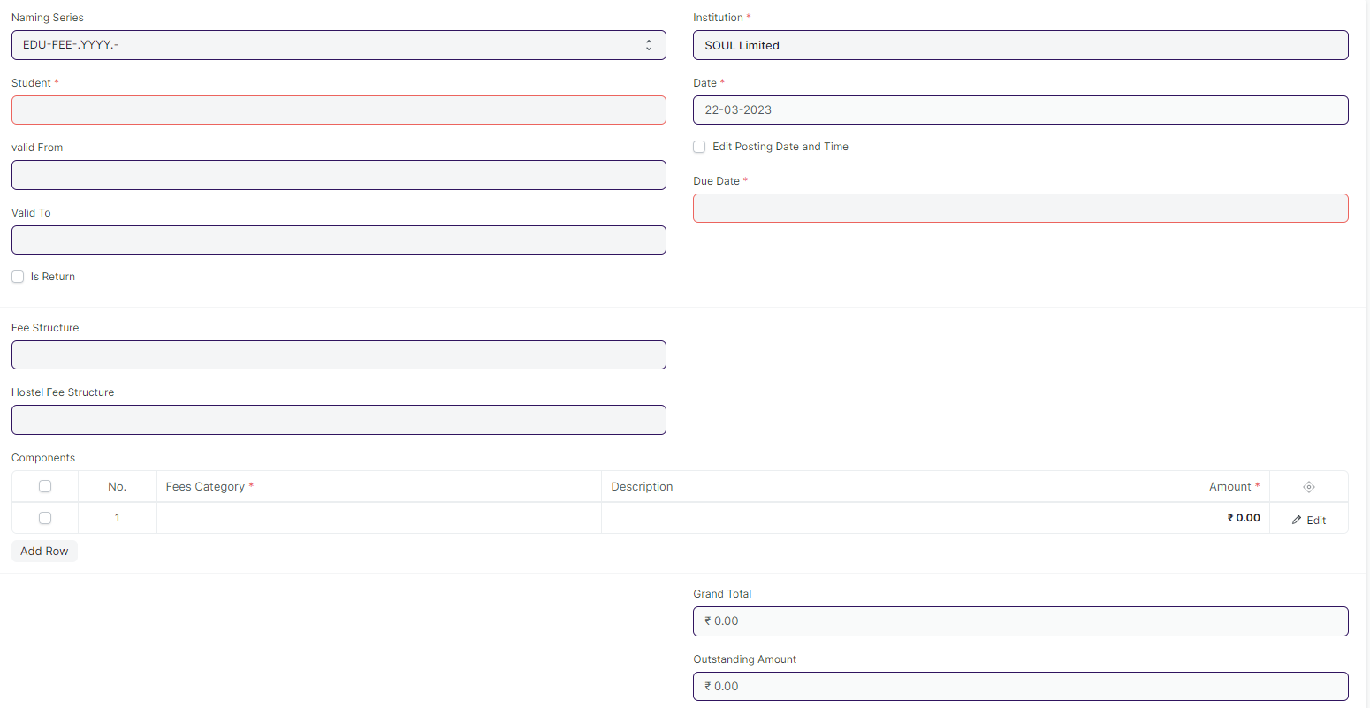**Screenshot**

Figure:Fees

**Field List**

The following table describes the UI fields present in this screen :

|  |  |  |  |  |  |  |
| --- | --- | --- | --- | --- | --- | --- |
| **ID** | **Field Name** | **Field Type** | **Mandatory** | **Action / Validation** | **Remarks** | **R/N/D** |
| 1 | Student | Link Field |  | Link Field to Student Screen |  |  |
| 2 | Student Name | Text | Yes | Student Name auto fetched when student id is entered |  |  |
| 3 | Roll No | Text |  | Roll No auto fetched when student id is entered |  |  |
| 4 | Registration Number | Text |  | Registration Number auto fetched when student id is entered |  |  |
| 5 | Fee Schedule | Link Field |  | Link Field to Fee Schedule Screen |  |  |
| 8 | Valid From | Date |  |  |  |  |
| 9 | Valid To | Date |  | Valid to date should be greater then Valid from date |  |  |
| 11 | Return Issued | Checkbox |  |  |  |  |
| 13 | Institution | Link Field | Yes | Link Fielded to Company Screen |  |  |
| 14 | Date | Date | Yes |  |  |  |
| 15 | Posting Time | Time |  |  |  |  |
| 16 | Edit Posting Date and Time | Checkbox |  |  |  |  |
| 17 | Due Date | Date | Yes |  |  |  |
| 19 | Program Enrollment | Link Field |  | Link Field to Program Enrollment Screen |  | (R) Course Enrollment |
| 20 | Programs | Link Field | Yes | Link Field to Programs Screen |  | (R) Course |
| 21 | Semester | Link Field | Yes | Link Field to Semester Screen |  |  |
| 22 | Student Batch | Link Field |  | Link Field to Student Batch Screen |  |  |
| 23 | Student Email | Text |  | Auto fetched when student id is entered |  |  |
| 25 | Student Category | Link Field |  | Link Fielded to Student Category Screen |  |  |
| 26 | Academic Term | Link Field |  | Link Fielded to Academic Term Screen |  |  |
| 27 | Academic Year | Link Field |  | Link Fielded to Academic Year Screen |  |  |
| 29 | Currency | Link Field |  | Link Fielded to Currency Screen |  |  |
| 30 | Fee Structure | Link Field |  | Link Fielded to Fee Structure Screen and filtered applied according to the Programs, Semester and Academic Term. |  |  |
| 31 | Hostel Fee Structure | Link Field |  | Link Fielded to Hostel Fee Structure Screen |  |  |
| 32 | **Components** | Table | Yes |  |  |  |
| 34 | Grand Total | Currency |  |  |  |  |
| 35 | In Words | Text |  |  |  |  |
| 36 | Outstanding Amount | Currency |  |  |  |  |
| 38 | Waiver Type | Drop down |  | Amount  Percentage |  |  |
| 39 | Percentage | Text |  |  |  |  |
| 40 | Amount | Currency |  |  |  |  |
| 41 | Waiver Amount | Currency |  |  |  |  |
| 43 | Letter Head | Link Field |  | Link Fielded to Letter Head Screen |  |  |
| 46 | Print Heading | Link Field |  | Link Fielded to Print Heading Screen |  |  |
| 47 | Cost Center | Link Field |  | Link Fielded to Cost Center |  |  |
| 48 | View | Button |  | Clicking this button shows a dropdown , containing 3 options:   1. Accounting Ledger 2. Payments 3. General Ledger w/ Cancellation | 1. Accounting : Links to Accounting Ledger Report Page 2. Payments: Links to Payment Entry Page 3. Links to General Ledger Report Page |  |
| 49 | Create | Button |  | Clicking this button shows a dropdown , containing 2 options:   1. Payment Request 2. Payment | 1. Payment Request: Redirects to payment request page where after submissions a payment request is created 2. Payment: Leads to Payment Entry Page where after saving and submitting a payment entry is generated |  |

|  |  |  |  |  |  |  |
| --- | --- | --- | --- | --- | --- | --- |
| **Fee Components** | | | | | | |
| **ID** | **Field Name** | **Field Type** | **Mandatory** | **Validation/Action** | **Remarks** | **R/N/D** |
| 1 | Fees Category | Link Field | Yes | Link Fields to master screen Fee Category and auto fetch from Fee Structure |  |  |
| 2 | Description | Long Text |  | auto fetch from Fee Structure |  |  |
| 3 | Amount | Currency | Yes | auto fetch from Fee Structure |  |  |
| 4 | Waiver Type | Dropdown |  | Amount  Percentage |  |  |
| 5 | Percentage | Float |  | auto fetch from Fee Structure |  |  |
| 6 | Waiver Amount | Currency |  |  |  |  |
| 7 | Total waiver Amount | Currency |  |  |  |  |
| 8 | Receivable Account | Link Field | Yes | Link Fields to Account Screen and auto fetch from Fee Structure |  |  |
| 9 | Income Account | Link Field | Yes | Link Fields to Account Screen and auto fetch from Fee Structure |  |  |
| 10 | Company | Link Field |  | Link Fields to Company Screen and auto fetch from Fee Structure |  |  |
| 11 | Grand Fee Amount | Currency |  |  |  |  |
| 12 | Outstanding Fees | Currency |  |  |  |  |

**Users: Roles and Permissions**

The following table describes the users and their roles and permissions for the screens :

|  |  |  |  |  |  |  |  |  |
| --- | --- | --- | --- | --- | --- | --- | --- | --- |
| **ID** | **Role** | **Read** | **Write** | **Create** | **Delete** | **Submit** | **Cancel** | **Amend** |
| 1 | Account User | Yes | Yes | Yes | Yes | No | No | No |
| 2 | Account Manager | Yes | Yes | Yes | No | Yes | No | No |
| 3 | Accountant Admin | Yes | Yes | Yes | Yes | Yes | Yes | Yes |
| 4 | Student | Yes | Yes | No | No | No | No | No |

### Program Enrollment

**General Description**

The following table describes overall information about this screen:

|  |  |
| --- | --- |
| **Description** | 1. Program Enrollment is the record of enrollment of a student in a given program and chosen courses for a particular Academic Term. 2. To ensure that students are associated with a particular program in the system, their Program Enrollment must be created. The mandatory course in that program is automatically filled in the Enrolled Courses table while the elective or optional courses can be selected manually. 3. If the student has applied online for the admission in a particular Program and the application is approved, then the Program Enrollment can be created from within the Student Applicant record via clicking on the Enroll button. |
| **Navigation** | Home > Education > Admission > Program Enrollment |
| **Pre-requisites** | Student  Fee Structure  Student Batch |
| **Existing Screen Name** | Program Enrollment |
| **New Screen Name** | Course Enrollment |

**Screenshot**

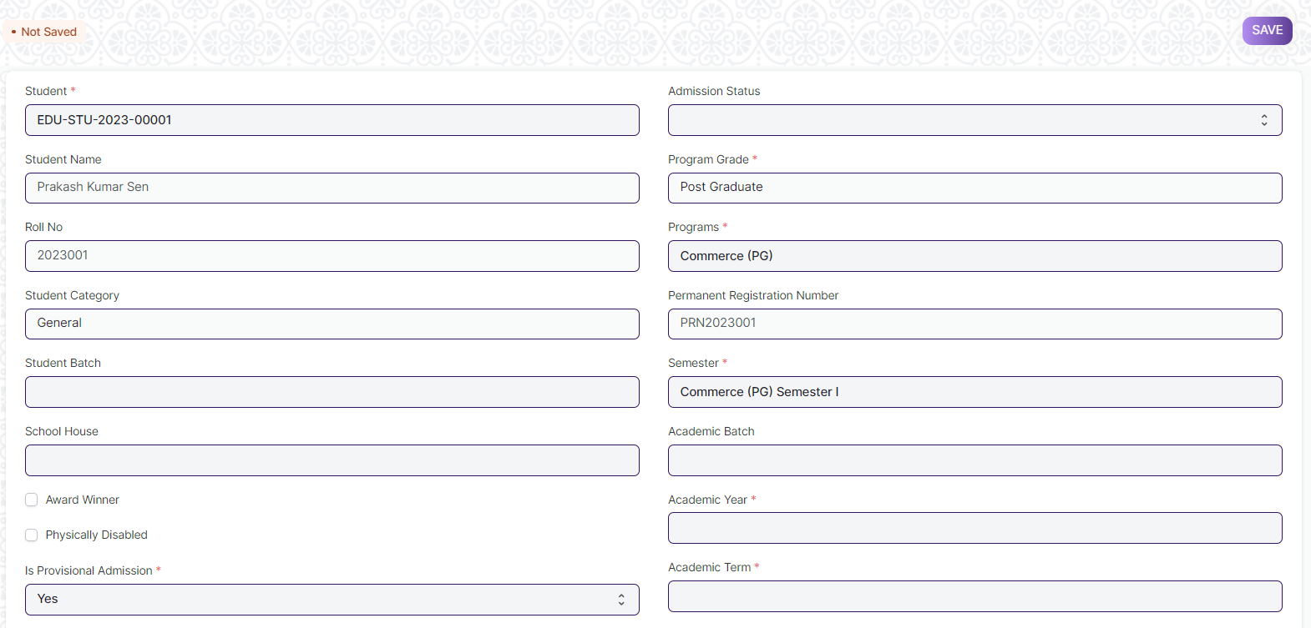 Figure: Program Enrollment

**Field List:**

The following table describes the UI fields present in this screen :

|  |  |  |  |  |  |  |
| --- | --- | --- | --- | --- | --- | --- |
| **ID** | **Field Name** | **Field Type** | **Mandatory** | **Validation / Action** | **Remarks** | **R/N/D** |
| 1 | Student | Link Field | Yes | Link Fields to master screen Student, auto fetched when clicked enrolled button from student or student Applicant screen. |  |  |
| 2 | Student Name | Read Only |  | Auto fetched when student id is inputted. |  |  |
| 3 | Roll No | Text |  |  |  |  |
| 4 | Gender | Link Field |  | Link Fields to master screen Gender, auto fetched when clicked enrolled connection button from student screen or enroll button from student applicant screen. |  |  |
| 5 | Student Category | Link Field |  | Link Fields to master screen Student Category, auto fetched when clicked enrolled connection button from student screen or enroll button from student applicant screen |  |  |
| 6 | Student Batch | Link Field |  | Link Fields to master screen Student Batch Name |  |  |
| 7 | School House | Link Field |  | Link Fields to master screen School House |  |  |
| 8 | Physically Disabled | Checkbox |  |  |  |  |
| 9 | Is Provisional Admission | Dropdown | Yes | Yes  No |  |  |
| 10 | Admission Status | Dropdown |  | Provisional Admission  Admitted |  |  |
| 11 | Program Grade | Link Field |  | Link Fields to master screen Program Grade |  | (R) Course Grade |
| 12 | Programs | Link Field |  | Link Fields to master screen Programs and filtered on the basis of program grade |  | (R) Courses |
| 13 | Permanent Registration Number | Text |  |  |  |  |
| 14 | Program | Link Field | Yes | Link Fields to master screen Semester and filtered on the basis of programs |  | (R) Semester |
| 15 | Academic Batch | Text |  |  |  | (D) |
| 16 | Academic Year | Link Field | Yes | Link Fields to master screen Academic Year auto fetched when clicked enrolled connection button from student screen. And enroll button form student applicant screen. |  |  |
| 17 | Academic Term | Link Field |  | Link Fields to master screen Academic Term |  |  |
| 18 | Year End Date | Date |  |  |  |  |
| 19 | Enrollment Date | Date | Yes |  |  |  |
| 20 | Seat Reservation Type | Link Field |  | Link Fields to master screen Seat Reservation Type and fetched on the basis student category wise seat reservation |  |  |
| 21 | Available seats | Number |  | Auto fetched from Student admission screen child table Reservation distribution table. |  |  |
| 22 | Boarding Student | Checkbox |  |  |  |  |
|  |  |  |  |  |  |  |
| 23 | **Courses** | Table |  | Description of the table is given below as programmed Enrolled Courses |  | (R) Modules |
|  |  |  |  |  |  |  |
| 25 | Vehicle/Bus Number |  |  |  |  |  |
| 26 | Due Date | Date |  |  |  |  |
| 27 | **Fee Structure Item** | Table |  | 1. Once program enrollment record submitted for a particular student then in back-end the fees record for that particular student will created and then the student need to pay their fees from the Fees screen.   2. Description of this table is given below. |  |  |
| 28 | Image | Attach Image |  | 1. On attachment a dialogue box will be popup where user can attach the images, take the picture with the help camera. 2. If photos or images attached then the size will be maximum 200 kb. |  |  |
| 29 | **Academic Calendar** | Table |  | Description of this table is given below. |  |  |
| 30 | Voucher No. | Text Field |  |  |  |  |
| 31 | Company | Text Field |  |  |  |  |
| 32 | Submit | | | On submit the record the course enrollment auto created and student will be enrolled on those courses which are present in **course** child table |  |  |

|  |  |  |  |  |  |  |
| --- | --- | --- | --- | --- | --- | --- |
| **Program Enrollment Course** | | | | | | |
| **ID** | **Field Name** | **Field Type** | **Validation/Action** | **Mandatory** | **Remarks** | **R/N/D** |
| 1 | Course | Link Field |  | Yes | Link Fields to master screen Course, and those courses will be visible which are linked with inputted semester | (R) Module |
| 2 | Course Code | Text |  |  |  | (R) Module Code |
| 3 | Course Name | Text |  |  |  | (R) Module Name |
| 4 | Instructor | Link Field |  |  | Link Fields to master screen Instructor | (R) Trainer |
| 5 | Credit Allocation | Button |  |  |  | (D) |

|  |  |  |  |  |  |  |
| --- | --- | --- | --- | --- | --- | --- |
| **Fee Structure Item** | | | | | | |
| **ID** | **Field Name** | **Field Type** | **Validation/Action** | **Mandatory** | **Remarks** | **R/N/D** |
| 1 | Student Category | Link Field |  |  | Link Fields to master screen Student Category |  |
| 2 | Fee Structure | Link Field |  | Yes | Link Fields to master screen Fee Structure |  |
| 3 | Amount | Currency |  |  |  |  |
| 4 | Due Date | Date |  | Yes |  |  |

|  |  |  |  |  |  |  |
| --- | --- | --- | --- | --- | --- | --- |
| **Academic Calendar** | | | | | | |
| **ID** | **Field Name** | **Field Type** | **Validation/Action** | **Mandatory** | **Remarks** | **R/N/D** |
| 1 | Academic Events | Link Field |  | Yes | Link Fields to master screen Academic Events, events will fetch w.r.t Academeic Calendar Template |  |
| 2 | Start Date | Date |  | Yes | Start date will fetch w.r.t Academeic Calendar Template |  |
| 3 | End Date | Date |  | Yes | End date will fetch w.r.t Academeic Calendar Template |  |
| 4 | Duration | Number |  |  | Duration will fetch w.r.t Academeic Calendar Template |  |

**Users: Roles and Permissions**

The following table describes the users and their roles and permissions for the screens :

|  |  |  |  |  |  |  |  |  |
| --- | --- | --- | --- | --- | --- | --- | --- | --- |
| **ID** | **Role** | **Read** | **Write** | **Create** | **Delete** | **Submit** | **Cancel** | **Amend** |
| 1 | Admin | Yes | Yes | Yes | Yes | Yes | Yes | Yes |
| 2 | Instructor | Yes | No | No | No | No | No | No |
| 3 | Student | Yes | No | No | No | No | No | No |

### Student Re registration Tool

**General Description**

The following table describes overall information about this screen:

|  |  |
| --- | --- |
| **Description** | Student Re registration tool mainly help for enrolling the students into their next semester bulk wise only after the enrollment of first semester. |
| **Navigation** | | Home > Admission > Tools > Student Re registration |
| **Pre-requisites** | 1. Program Enrollment up-to first semester 2. Semester 3. Academic Year 4. Academic Term 5. Student Batch |

**Screenshot**

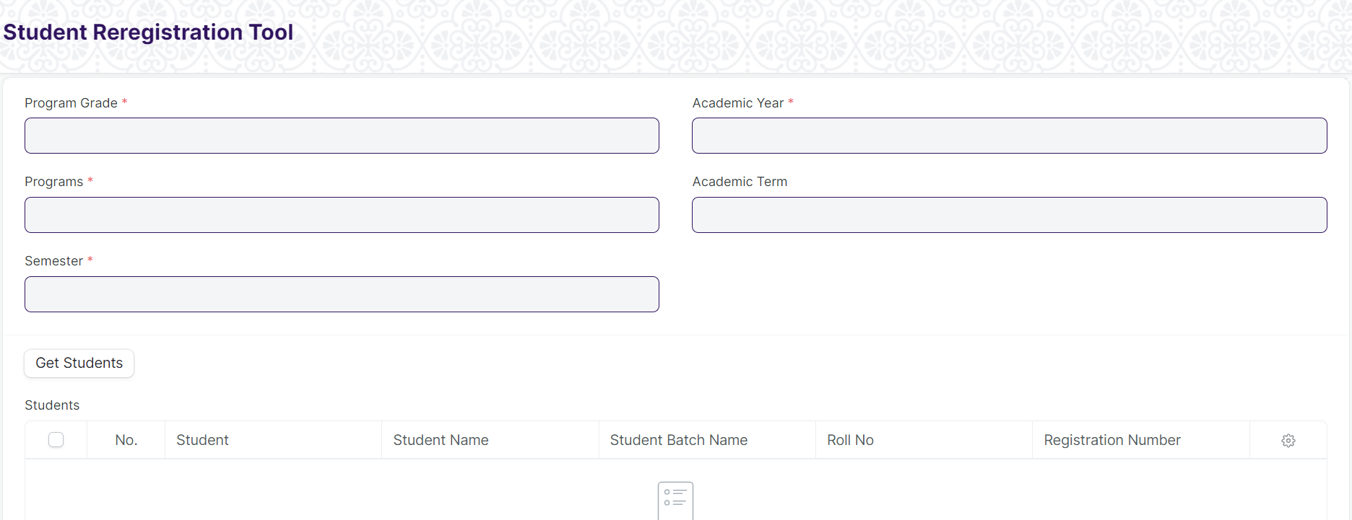

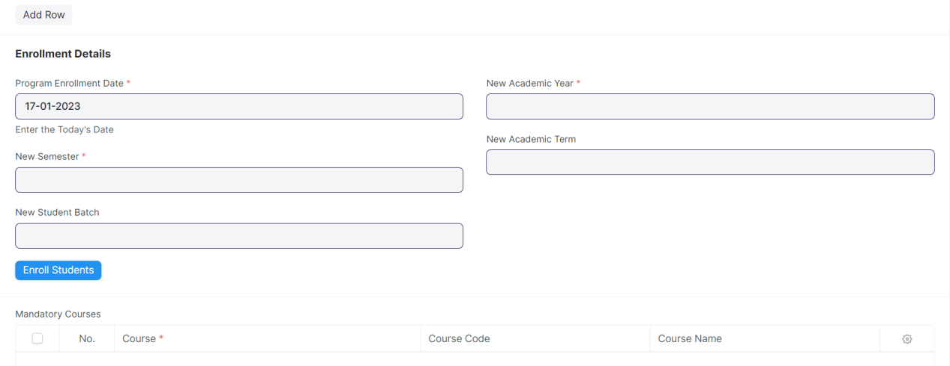

Figure: Student Re registration Tool Screen

**Field List**

The following table describes the UI fields present in this screen :

|  |  |  |  |  |  |  |
| --- | --- | --- | --- | --- | --- | --- |
| **ID** | **Field Name** | **Field Type** | **Mandatory** | **Validation / Action** | **Remarks** | **R/N/D** |
| 1 | Program Grade | Link Field | Yes | Linked to Program Grade Screen |  | (R) Course Grade |
| 2 | Programs | Link Field | Yes | Linked to Programs Screen |  | (R) Course |
| 3 | Program | Link Field | Yes | Linked to Semester Screen |  | (R) Semester |
| 4 | Student Batch | Link Field |  |  |  |  |
| 5 | Academic Year | Link Field | Yes | Linked to Academic Year Screen |  |  |
| 6 | Academic Term | Link Field | Yes | Linked to Academic Term Screen |  |  |
| 7 | Get Students | Button |  |  |  |  |
| 8 | Students | Table |  | **Auto Generated the student List** |  |  |
| 9 | Program Enrollment Date | Date | Yes | Need to give the today’s date |  | (R) Course enrollment |
| 10 | New Semester | Link Field | Yes | Linked to Semester Screen |  |  |
| 11 | New Student Batch | Link Field | Yes |  |  |  |
| 12 | Enroll Students | Button |  |  |  |  |
| 13 | New Academic Year | Link Field | Yes | Linked to Academic Year Screen |  |  |
| 14 | New Academic Term | Link Field | Yes | Linked to Academic Term Screen |  |  |
| 15 | Mandatory Courses | Table |  |  |  |  |

|  |  |  |  |  |  |  |
| --- | --- | --- | --- | --- | --- | --- |
| **Students** | | | | | | |
| **ID** | **Field Name** | **Field Type** | **Mandatory** | **Validation / Action** | **Remarks** | **R/N/D** |
| 1 | Student | Link Field |  |  |  |  |
| 2 | Student Name | Text |  |  |  |  |
| 3 | Roll Number | Text |  |  |  |  |

|  |  |  |  |  |  |  |
| --- | --- | --- | --- | --- | --- | --- |
| **Mandatory Courses** | | | | | | |
| **ID** | **Field Name** | **Field Type** | **Mandatory** | **Validation / Action** | **Remarks** | **R/N/D** |
| 19 | Course | Link Field |  |  |  | (R) Module |
| 20 | Course Name | Text |  |  |  | (R) Module Name |

**Users: Roles and Permissions**

The following table describes the users and their roles and permissions for the screens :

|  |  |  |  |  |  |  |  |  |
| --- | --- | --- | --- | --- | --- | --- | --- | --- |
| **ID** | **Role** | **Read** | **Write** | **Create** | **Delete** | **Submit** | **Cancel** | **Amend** |
| 1 | Admin | Yes | Yes | Yes | Yes | NA | NA | NA |

### Fee Waiver

**General Description**

|  |  |
| --- | --- |
| **Description** | Fee waiver refers to an exemption or reduction of a student's fees that they would normally be required to pay in order to enroll in classes or participate in certain activities. |
| **Navigation** |  |
| **Pre-requisites** | Student  Fee Structure  Program  Semester  Academic Year  Academic Term |
| **Existing Screen Name** |  |
| **New Screen Name** |  |

**Screenshot**

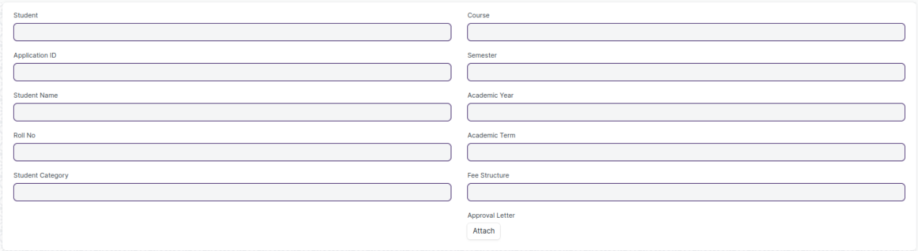

Figure: Fee Waiver Screen

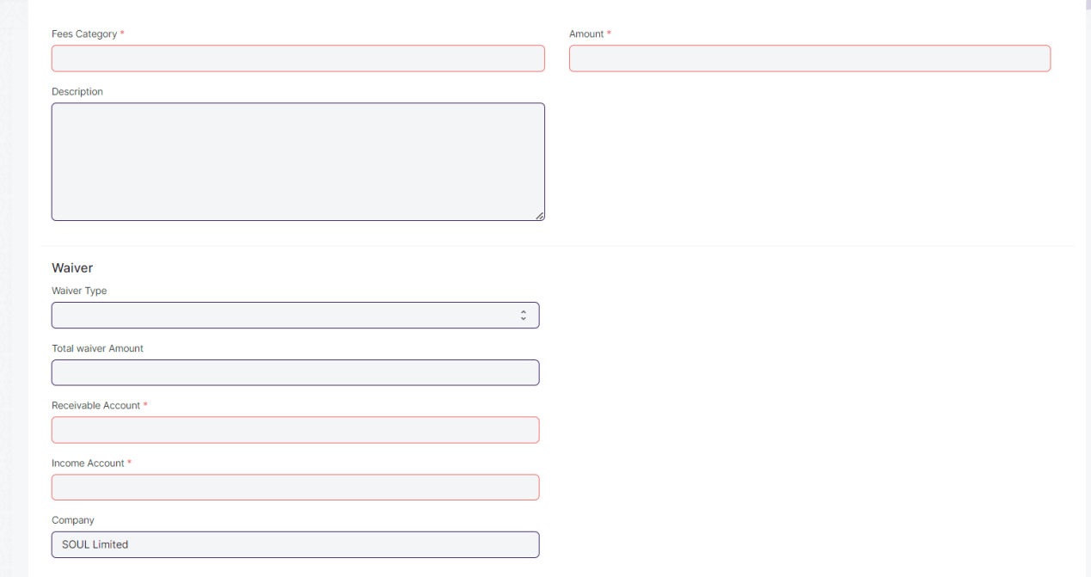

Figure 9 : Fee Components Table

**Field List**

The following table describes the UI fields present in this screen :

|  |  |  |  |  |  |  |
| --- | --- | --- | --- | --- | --- | --- |
| **ID** | **Field Name** | **Field Type** | **Validation/ Action** | **Mandatory** | **Remarks** | **R/N/D** |
|  | Student | Link Field | If the Fee waiver checkbox on the Student screen is checked, then the student's id will be fetched. | Y | Users can search for students based on student id or applicant id | N |
|  | Applicant ID | Link Field | If Applicant ID present in student master screen then it will fetched from student master otherwise it will be blank. |  |  | N |
|  | Student Name | Data | Fetched from student master screen |  |  | N |
|  | Roll No | Data | Fetched from student master screen |  |  | N |
|  | Student Category | Data | Fetched from student master screen |  |  | N |
|  | Course | Link Field | If the student applicant has specified course priority, only that will be displayed and the user must choose from those. If the user has already enrolled in a course, that course will be fetched automatically. Otherwise, all courses will be fetched from the courses master screen and the user will have to choose from those. |  |  | N |
|  | Semester | Link Field | If the student applicant has specified semester, only that will be displayed and the user have to select that semester. If the user has already enrolled in a semester, that semester will be fetched automatically. Otherwise, all semester will be fetched from the semester master screen, filter will be applied based on selected course and the user will have to choose from those. |  |  | N |
|  | Academic Year | Link Field | If the student applicant has specified academic year, only that will be displayed and the user have to select that academic year. If the user has already enrolled in a academic year, that academic year will be fetched automatically. Otherwise, all academic year will be fetched from the academic year master screen, and the user will have to choose from those. |  |  | N |
|  | Academic Term | Link Field | If the student applicant has specified a academic term, only that will be displayed and the user have to select that academic term. If the user has already enrolled in a academic term, that academic term will be fetched automatically. Otherwise, all academic term will be fetched from the academic term master screen, filter will be applied based on selected academic year and the user will have to choose from those. |  |  | N |
|  | Fee Structure | Link Field | Fetched from Fee Structure master screen and filter will be applied based on selected course and semester. | Y |  | N |
|  | Approval letter | Attachment |  |  |  |  |
|  | Fee Components | Table |  | Y | Description of the table is given below. | N |

|  |  |  |  |  |  |  |
| --- | --- | --- | --- | --- | --- | --- |
| **Fee Components** | | | | | | |
| **ID** | **Field Name** | **Field Type** | **Validation/ Action** | **Mandatory** | **Remarks** | **R/N/D** |
|  | Fee Category | Link Field | Fetched from the selected Fee Structure | y |  | N |
|  | Description | Small Text | Fetched from the selected Fee Structure |  |  | N |
|  | Waiver Type | Dropdown | User Input | Y | Dropdown options are: Percentage/Amount | N |
|  | Percentage | Float | User Input |  | If the selected waiver type is percentage, then the field will be displayed and it will be mandatory. | N |
|  | Waiver Amount | Currency | User Input |  | If the selected waiver type is amount, then the field will be displayed and it will be mandatory. | N |
|  | Total Waiver Amount | Currency | The amount of the waiver will be calculated based on the type of waiver selected, either as a fixed amount or as a percentage of the total amount. |  |  | N |
|  | Receivable Account | Link Field | Fetched from the selected Fee Structure | Y |  | N |
|  | Income Account | Link Field | Fetched from the selected Fee Structure | Y |  | N |
|  | Company | Link Field | Fetched from the selected Fee Structure |  |  | N |
|  | Grand Fee Amount | Currency | Fetched from the selected Fee Structure |  |  | N |
|  | Outstanding Fees | Currency | Fetched from the selected Fee Structure, the outstanding fees of the waiver will be calculated based on the type of waiver selected, either as a fixed amount or as a percentage of the total amount. |  |  | N |
|  | Amount | Currency | Fetched from the selected Fee Structure , the amount of the waiver will be calculated based on the type of waiver selected, either as a fixed amount or as a percentage of the total amount. | Y |  | N |

**Note:**

There would be two levels of approval. At the first level approval will be done by Education Admission Department and the first level approval will be done by Education Admission Head.

**User: Roles & Permission**

The following table describes the users and their roles and permissions for the screens :

|  |  |  |  |  |  |  |  |  |
| --- | --- | --- | --- | --- | --- | --- | --- | --- |
| **ID** | **Role** | **Read** | **Write** | **Create** | **Delete** | **Submit** | **Cancel** | **Amend** |
|  | Accountant Admin | Yes | Yes | Yes | Yes | Yes | Yes | Yes |
|  | Account Manager | Yes | Yes | Yes | No | Yes | Yes | Yes |
|  | Account User | Yes | Yes | Yes | No | Yes | Yes | Yes |